**Northrop Grumman Environmental Control System Door Latch**

**Assembly Manual**

**Tim Anderson**

**Andrea Hernandez**

**Sam Mangialardi**

**Alexander Soto**

**Jake West**

**Michael Wilson**

Contents

**Materials** 3

**Assembly** 4

**Disassembly** 12

**Operation** 13

**Troubleshooting** 14

# **Materials**

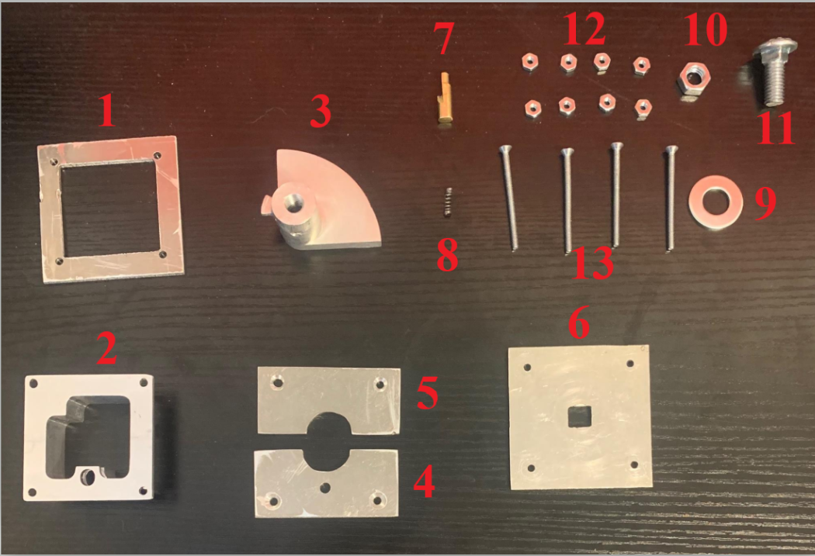

1. Sandwich Plate
2. Housing
3. Shaft
4. Top Plate #1
5. Top Plate #2
6. Back Plate
7. Pin
8. Compression Spring
9. Washer
10. Large Nut
11. Large Screw
12. Small Nut
13. Small Screw

# **Assembly**

1. Insert housing into fairing.

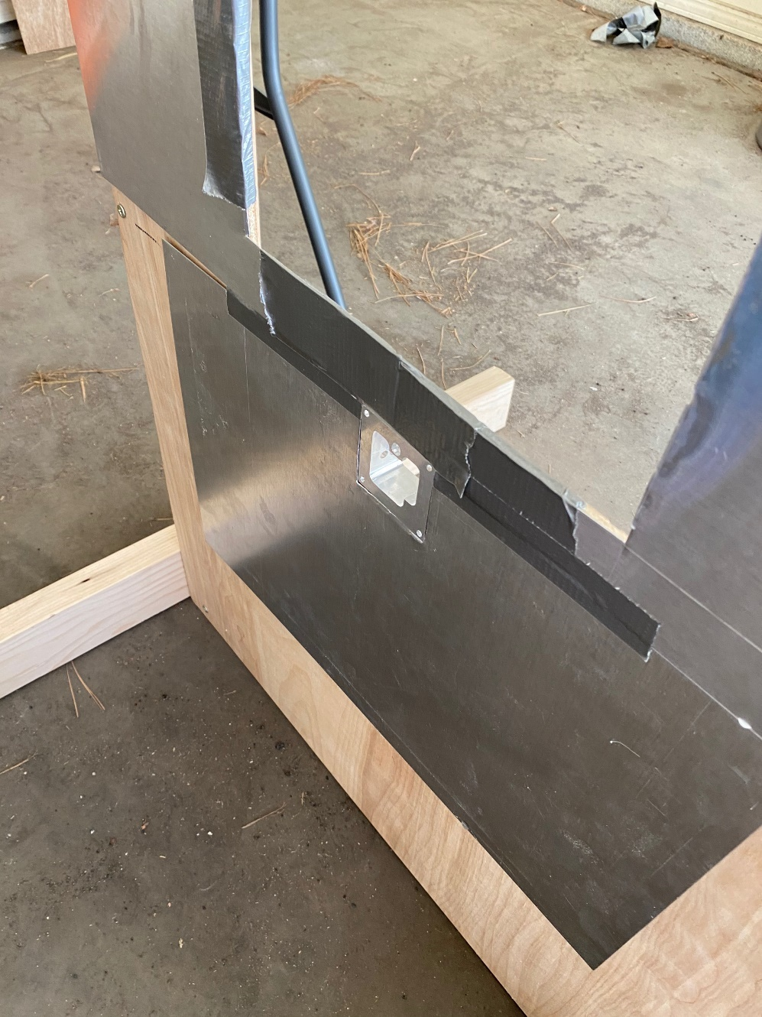

1. Slide sandwich plate onto housing from the inside of fairing.
2. Place torsion spring onto shaft by inserting bent torsion spring leg into small shaft hole.
   1. 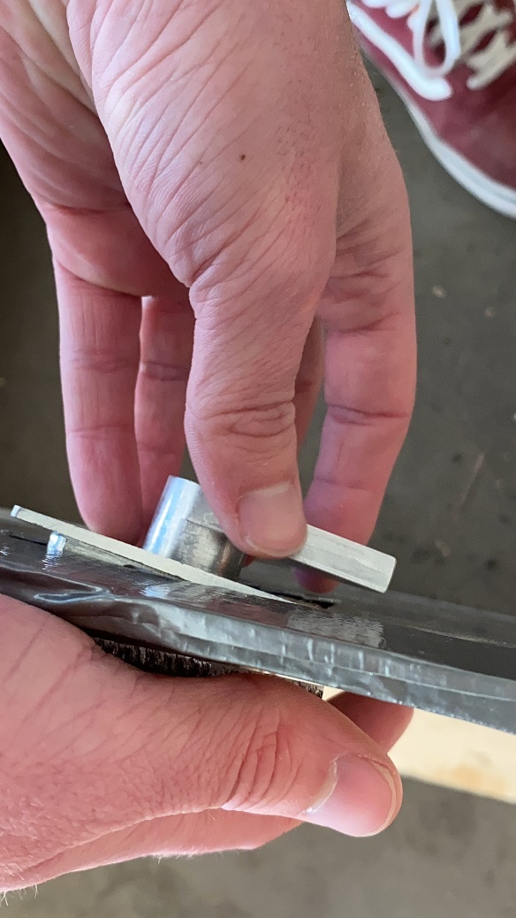If using alternative elastic potential device, IE Hair tie or rubber band, wrap one end around the tab on shaft then feed opposite end through hole on housing wall then wrap around bolts after step 11.

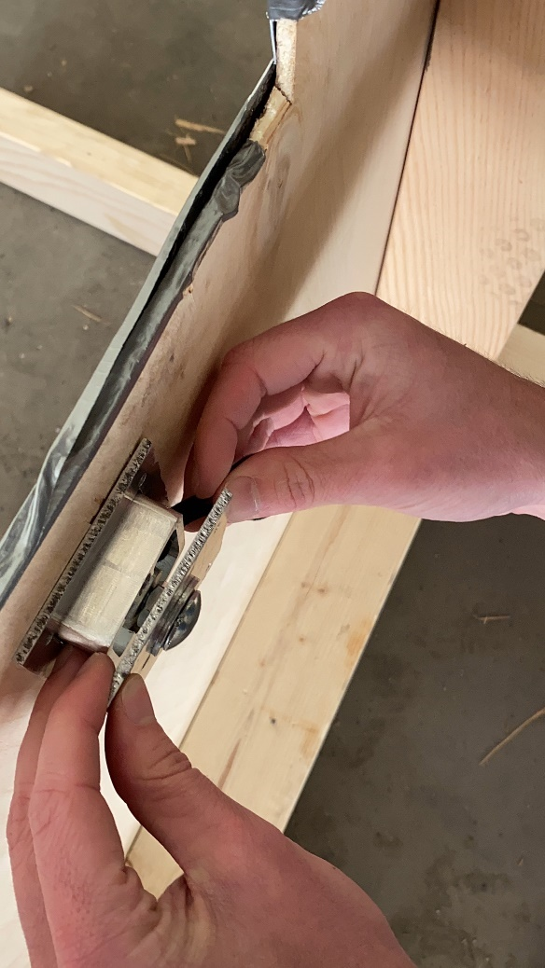

1. Assemble backplate with carriage bolt, nut, and washer.
   1. Insert bolt through backplate.
   2. insert washer on bolt and hand tighten nut onto the bolt.

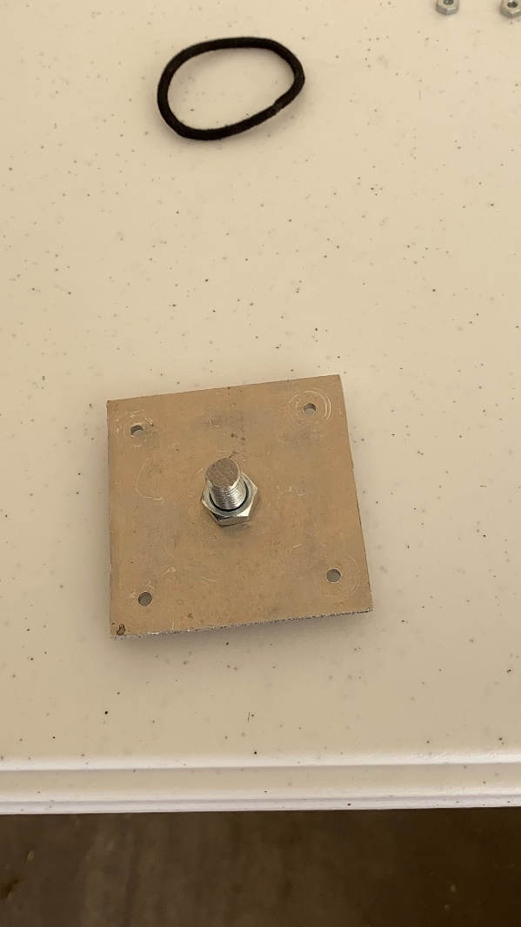

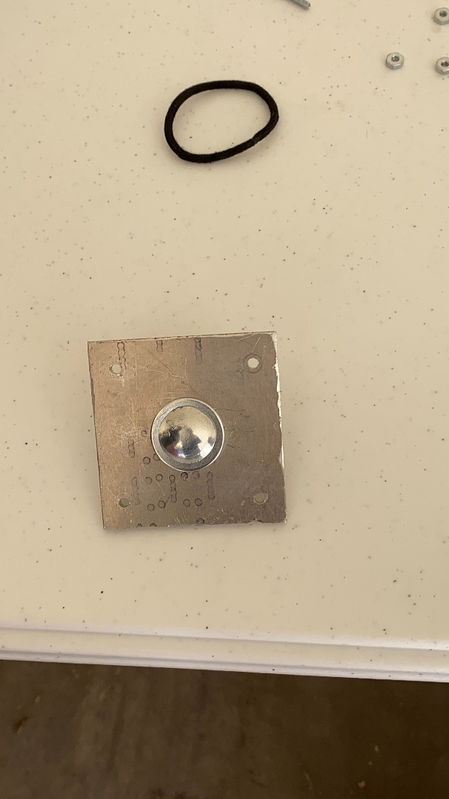

1. Thread bolt into shaft with shaft facing the outside of fairing.

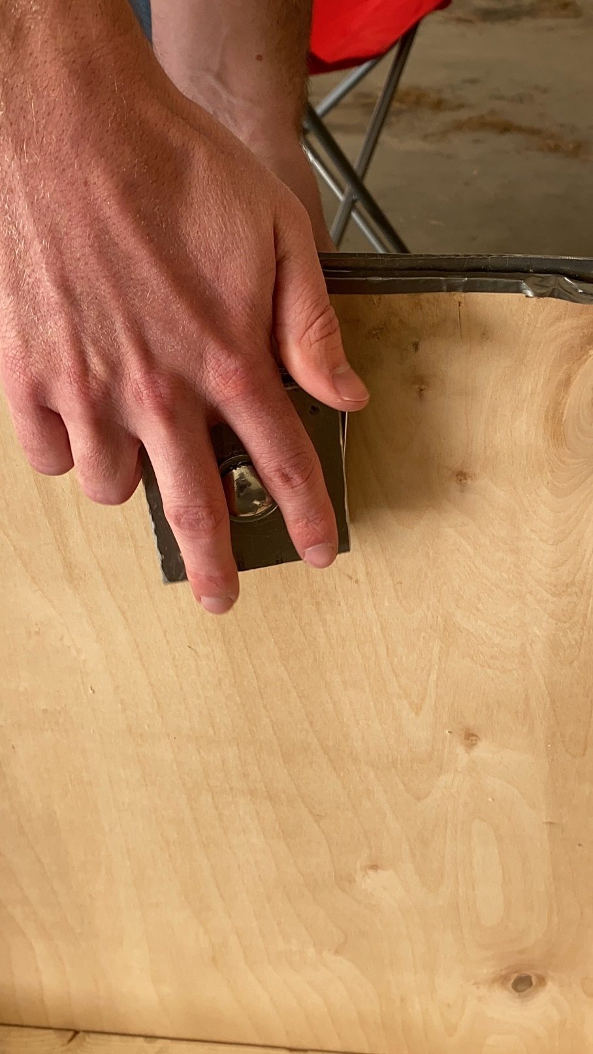

1. Hold the shaft’s tab in between pin housing slot until bottom plate contacts housing during threading.
2. Load torsion spring by twisting shaft 90 degrees counterclockwise.

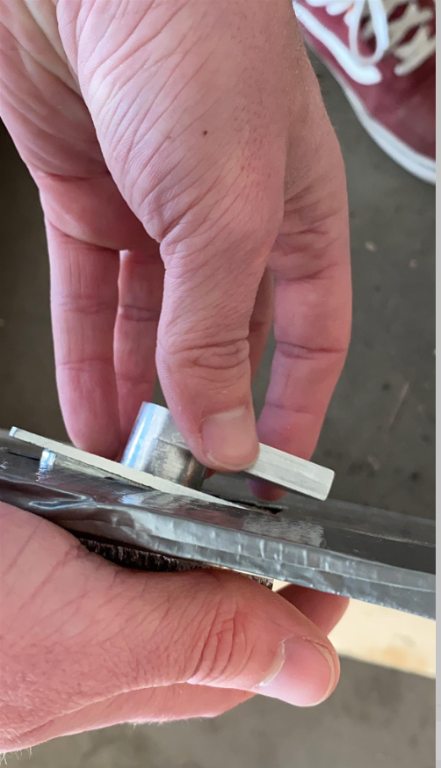

1. Insert compression spring and pin into pin housing with top plate #1 aligned with bolt holes with the pin passing through the middle hole.

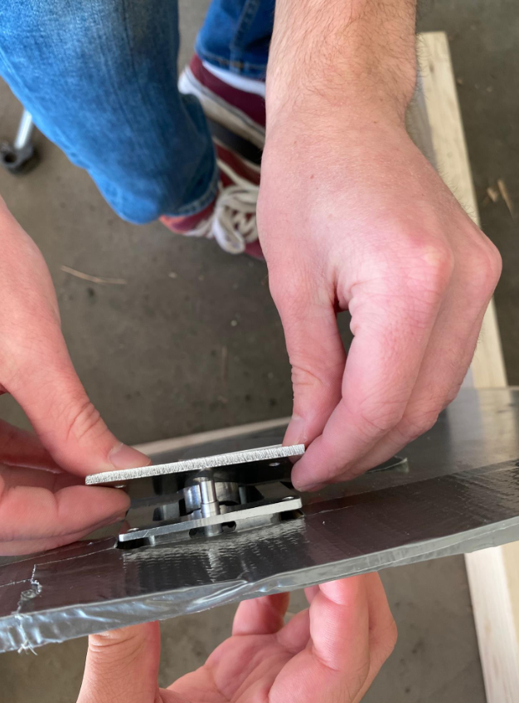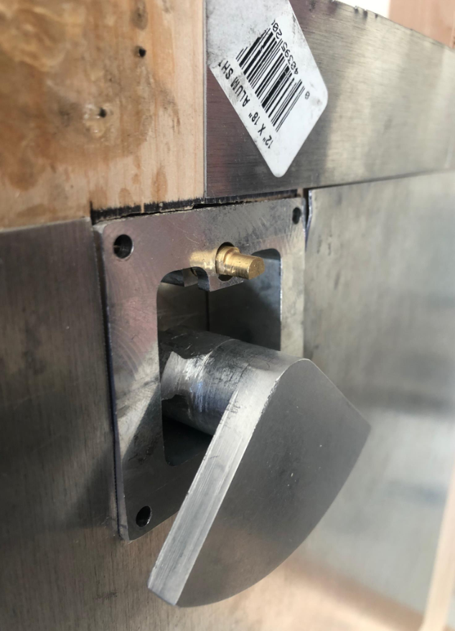

1. Insert bolts through the two open holes on top plate #1 with nuts in between the sandwich plate and back plate.

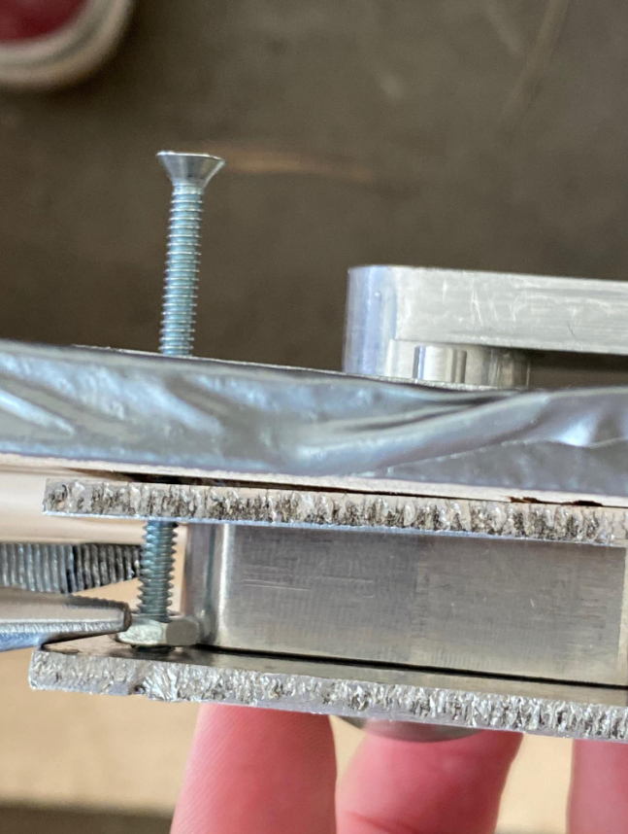

1. Align top plate #2 with the two open holes and insert two bolts with a nut in between the sandwich plate and back plate.
2. Insert nuts on the four exposed bolts to pull together the backplate to the rest of the device.

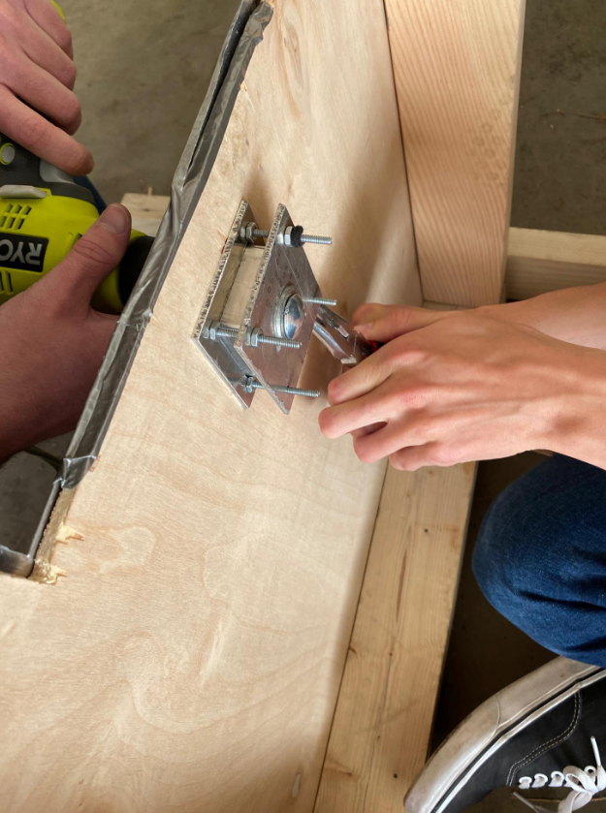

# **Disassembly**

1. Remove nuts from the four bolts that secure the backplate.
2. Unscrew bolts from front plates and remove nuts and bolts completely.
3. Take out the pin and compression spring from the front of the device.
4. Unscrew main bolt from the shaft and remove backplate and bolt assembly.
5. Remove sandwich plate from the back of the device.
6. Pull the housing out of the fairing from either direction.

# **Operation**

1. After assembly, turn the latch counterclockwise while holding down the pin, until the shafts extrusion clears the pin.
2. Release the pin, preventing the latch from spinning clockwise.
3. Allow the door to fall on the pin, letting the weight of the door push down the pin, activating the device.
4. To reset, lift door and turn the shaft clockwise until the pin pops back up and clicks into position.

# **Troubleshooting**

* **The pin has trouble compressing or does not pop out of the slot.**
* Check the compression spring to ensure it is still in the correct orientation. Make sure the spring is aligned with the pin and fits into the spring slot in the pin.
* The device will shift and move on different steps of assembly, it is best to install with a second person.